**LAB 10**

|  |  |
| --- | --- |
| **Name of the Student** | Saurabh Agarwal |
| **Roll Number** | J001 |
| **Course** | B.Tech Data Science |

**Codes:**

<https://colab.research.google.com/drive/17I2Ue7sUvz7DWEmZp57BBX8c8_t6Avw0>

<https://colab.research.google.com/drive/1GQ7Qj9TG7rOS5aw6fI2PM5MNFonTMCX7>

<https://colab.research.google.com/drive/1ac7jfrfE9K-uLgSRm73NKeATRRfeYaBL>

**Bottleneck Features:**

loss: 1.8269e-06 - accuracy: 1.0000 - val_loss: 6.7434 - val_accuracy: 0.4771

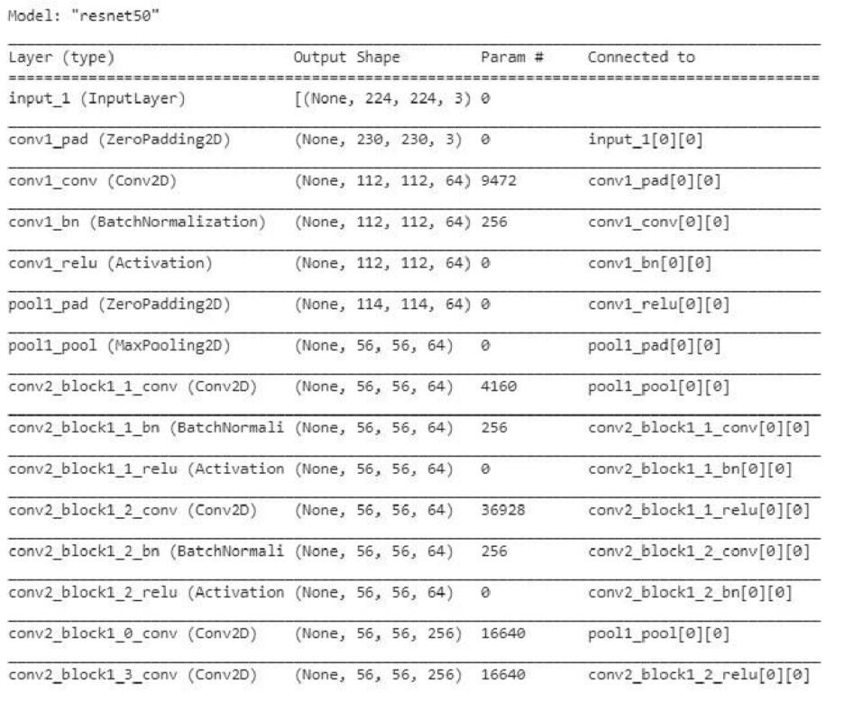

**Transfer Learning:**

